1. Takes note of the existence of standards and safety regulations (NEN-EN-ISO, Safety of Machinery)
2. Knows where to find standards that are applicable to the robotsthey are developing or working on
3. Knows the basics about what has to be done to market a product in terms of certification and regulation, and knows where to retrieve more information.
4. Learns to apply the most important aspects of machine safety regulations and risk assessment according to ISO 12100, ISO 10218 part 1 and 2 to both hardware and software of the products they develop
5. Learns to apply and gain insight in available risk reducing measures, including several sensors and calculating e.g. safe distance
6. Takes note of ISO 13849-1 (the safety-related parts of control systems)

# Question 1

NEN: NEderlandse Normen

ISO: Internationale Organisatie voor Standaardisatie

# Question 2

ISO 12100: This contains the Safety of machinery.

ISO 10218-1: Safety requirements for industrial robots part 1.

ISO 10218-2: Safety requirements for industrial robots part 2.

ISO 13849-1: Safety-related parts of control systems.

ISO TS 15066: Specific safety requirements of collaborative industrial robot systems.

# Question 3:

Moet voldoen aan de wetgeving en hiervoor kan je de machinerichtlijnen nastreven.

<https://ec.europa.eu/growth/single-market/european-standards/harmonised-standards/machinery_en>

# Question 4:

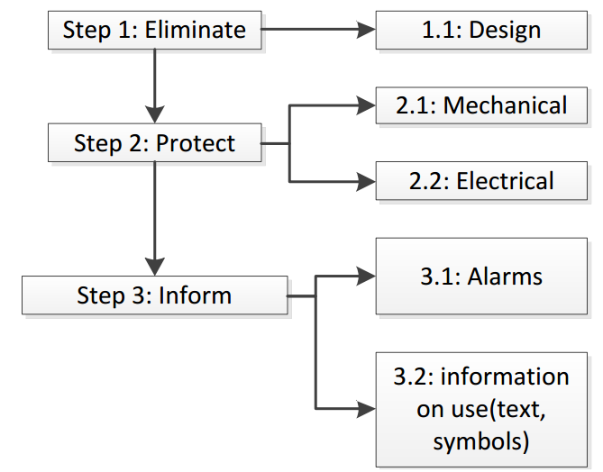

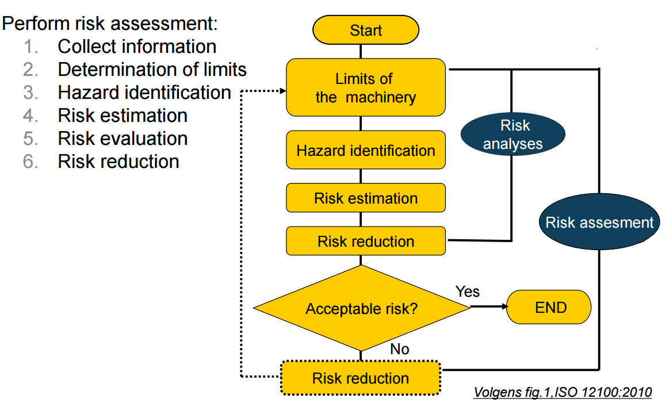

# Question 6

**ISO 13849-1**:2006 provides safety requirements and guidance on the principles for the design and integration of safety-related parts of control systems (SRP/CS), including the design of software. For these parts of SRP/CS, it specifies characteristics that include the performance level required for carrying out safety functions. It applies to SRP/CS, regardless of the type of technology and energy used (electrical, hydraulic, pneumatic, mechanical, etc.), for all kinds of machinery. It does not specify the safety functions or performance levels that are to be used in a particular case.

ISO 13849-1:2006 provides specific requirements for SRP/CS using programmable electronic system(s).